Food & Drink

กุลสตรี แสดงคุณ 632110335

บุรัสกร กมลเลิศ 632110344

พีรยา บุญยะวิโรจน์ 632110349

เสาวลักษณ์ เจียวใช่เฮ็ง 632110357

รายงานฉบับนี้เป็นส่วนหนึ่งของการเรียนวิชา960231

สาขาวิชาบูรณาการอุตสาหกรรมดิจิตอล มหาวิทยาลัยเชียงใหม่

ภาคเรียนที่ 1 ปีการศึกษา 2564

Api

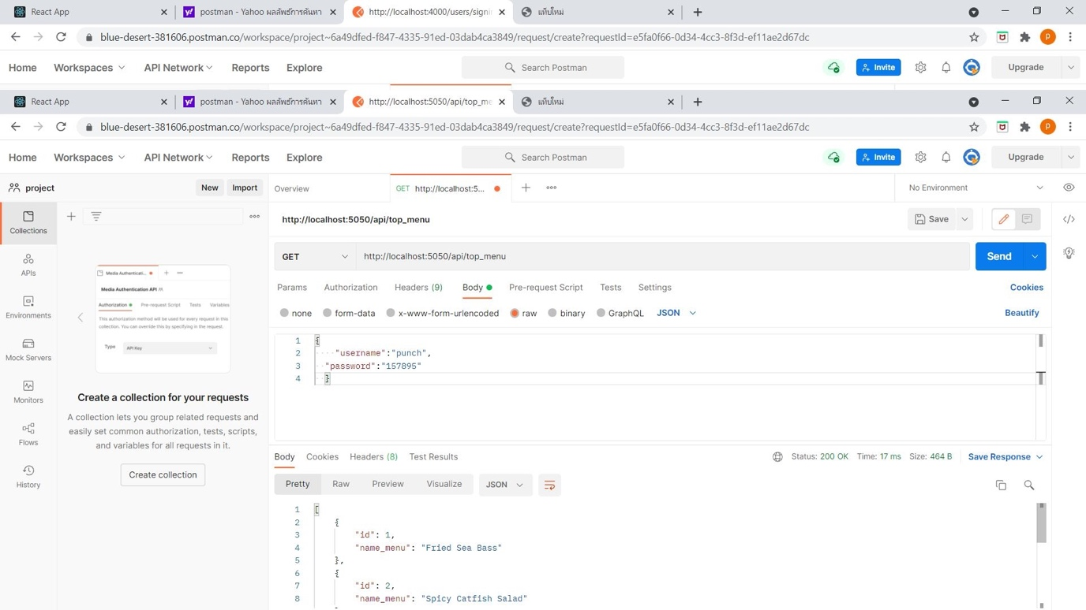

app.get('/api/top_menu', (req, res) => {

const sql = "SELECT id, name_menu FROM menu LIMIT 5";

connect.query(sql, (err, result) => {

if (err) {

throw err;

} else {

return res.status(200).json(result);

}

});

});

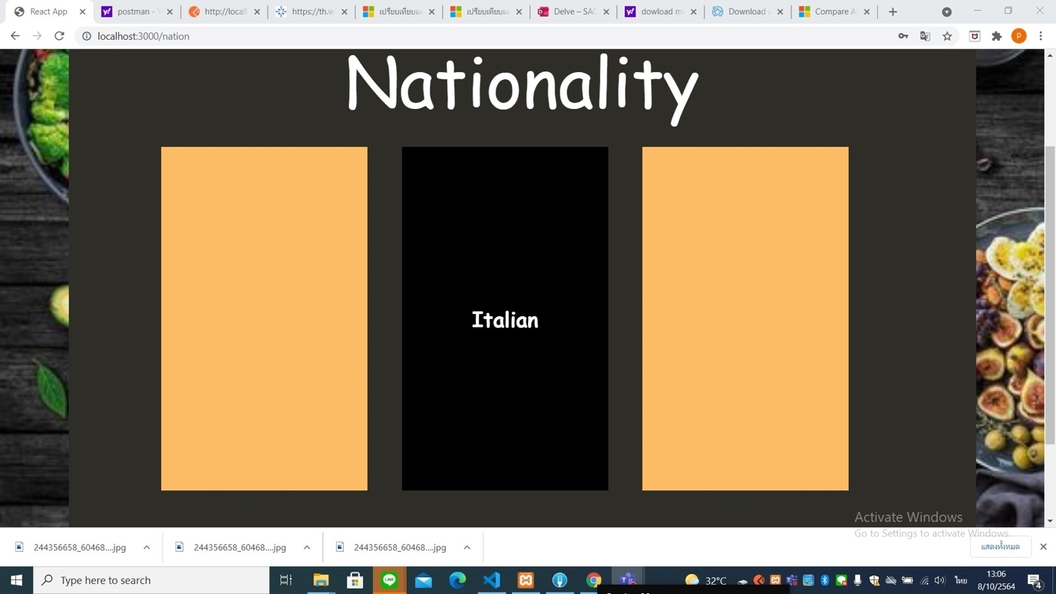

app.get('/api/randomNation', (req,res) => {

const randomNation = req.query.randomNation;

const arr = randomNation.split(',');

const sql = "SELECT * FROM nation WHERE id IN (?)";

connect.query(sql, [arr], (err, result) => {

if (err) {

throw err;

} else {

return res.status(200).json(result);

}

})

})

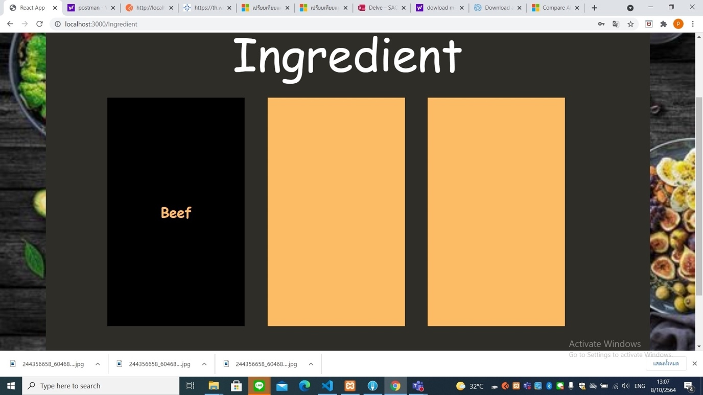

app.get('/api/randomIngredient', (req,res) => {

const randomIngredient = req.query.randomIngredient;

const arr = randomIngredient.split(',');

const sql = "SELECT * FROM ingredient WHERE In_id IN (?)";

connect.query(sql, [arr], (err, result) => {

if (err) {

throw err;

} else {

return res.status(200).json(result);

}

})

})

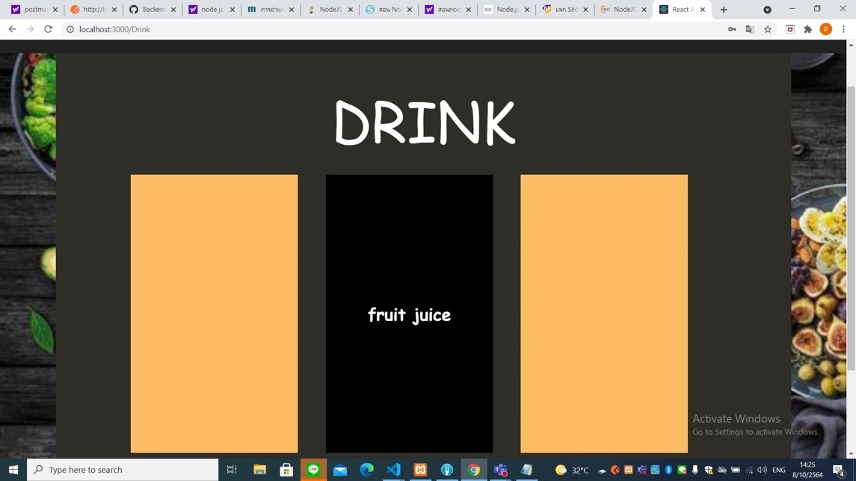

app.get('/api/randomDrink', (req,res) => {

const randomDrink = req.query.randomDrink;

const arr = randomDrink.split(',');

const sql = "SELECT * FROM ingredient WHERE In_id LIMIT 6,12";

let count = 0;

connect.query(sql, [arr], (err, result) => {

if (err) {

throw err;

} else {

let data = []

arr.forEach((id) => {

result.forEach((item) => {

if (item.In_id == id) {

data.push(item);

}

})

})

return res.status(200).json(data);

}

});

});

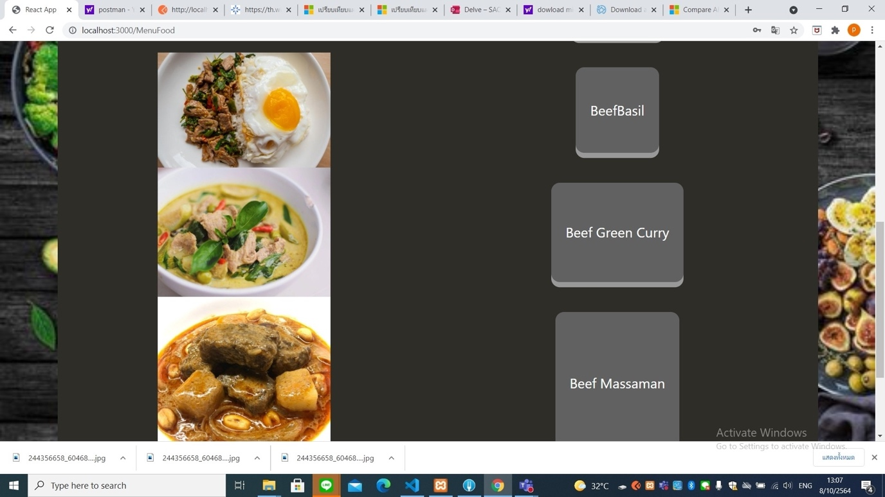

app.get('/api/menuFood',(req,res)=>{

const nation = req.query.nt;

const ing = req.query.ing;

const sql = "SELECT menu.name_menu, menu.image_menu FROM menu INNER JOIN ingredient ON menu.In_id = ingredient.In_id INNER JOIN nation ON menu.nt_id = nation.id WHERE ingredient.Ingredient_name = ? AND nation.nation_name = ?";

connect.query(sql, [ing, nation], (err, result) => {

if (err) {

throw err;

} else {

return res.status(200).json(result);

}

});

})

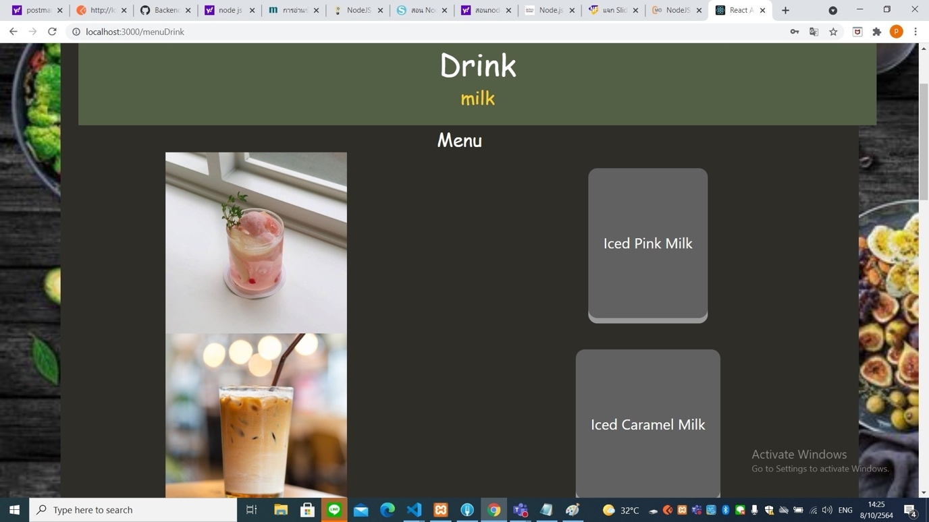

app.get('/api/menuDrink',(req,res)=>{

const ing = req.query.ing;

const sql = "SELECT menu_drink.name_menu, menu_drink.image_menu, ingredient.Ingredient_name FROM menu_drink INNER JOIN ingredient ON menu_drink.In_id = ingredient.In_id WHERE ingredient.Ingredient_name = ?";

connect.query(sql, [ing], (err, result) => {

if (err) {

throw err;

} else {

return res.status(200).json(result);

}

});

})

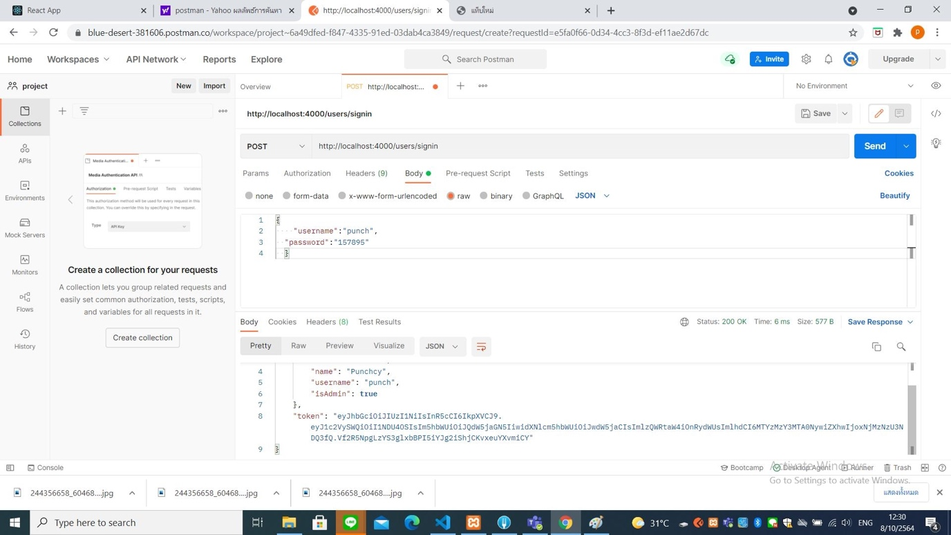

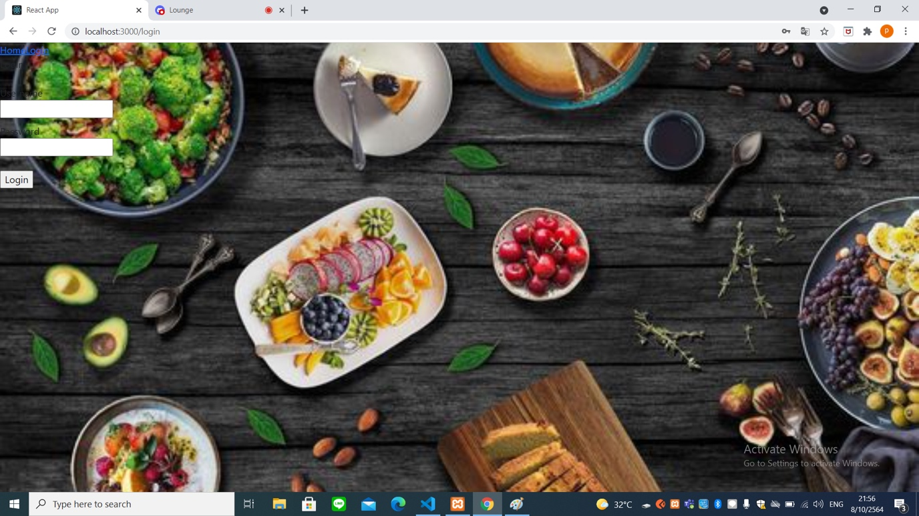

app.post('/users/signin', function (req, res) {

const user = req.body.username;

const pwd = req.body.password;

// return 400 status if username/password is not exist

if (!user || !pwd) {

return res.status(400).json({

error: true,

message: "Username or Password required."

});

}

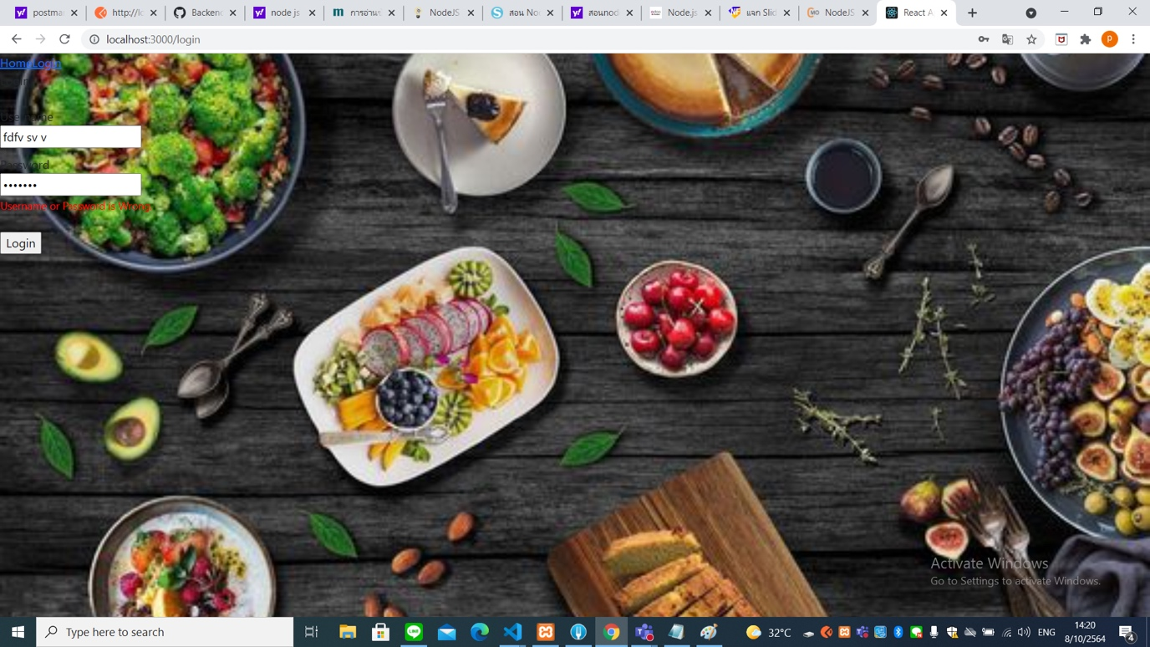

app.post('/users/signin', function (req, res) {

const user = req.body.username;

const pwd = req.body.password;

// return 400 status if username/password is not exist

if (!user || !pwd) {

return res.status(400).json({

error: true,

message: "Username or Password required."

});

}

// return 401 status if the credential is not match.

if (user !== userData.username || pwd !== userData.password) {

return res.status(401).json({

error: true,

message: "Username or Password is Wrong."

});

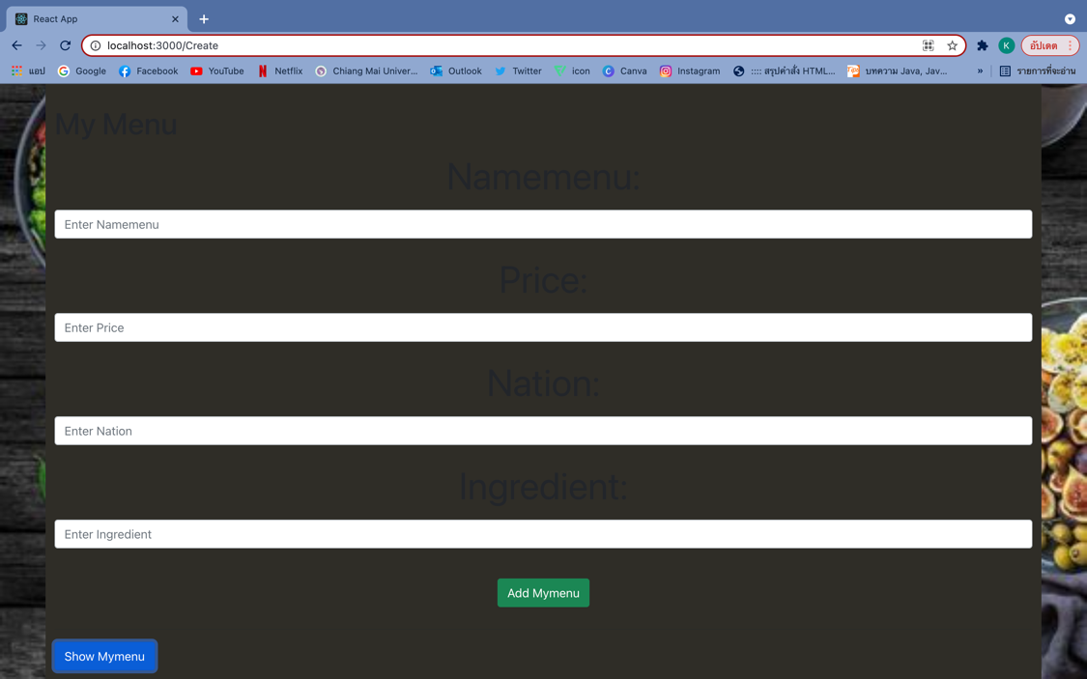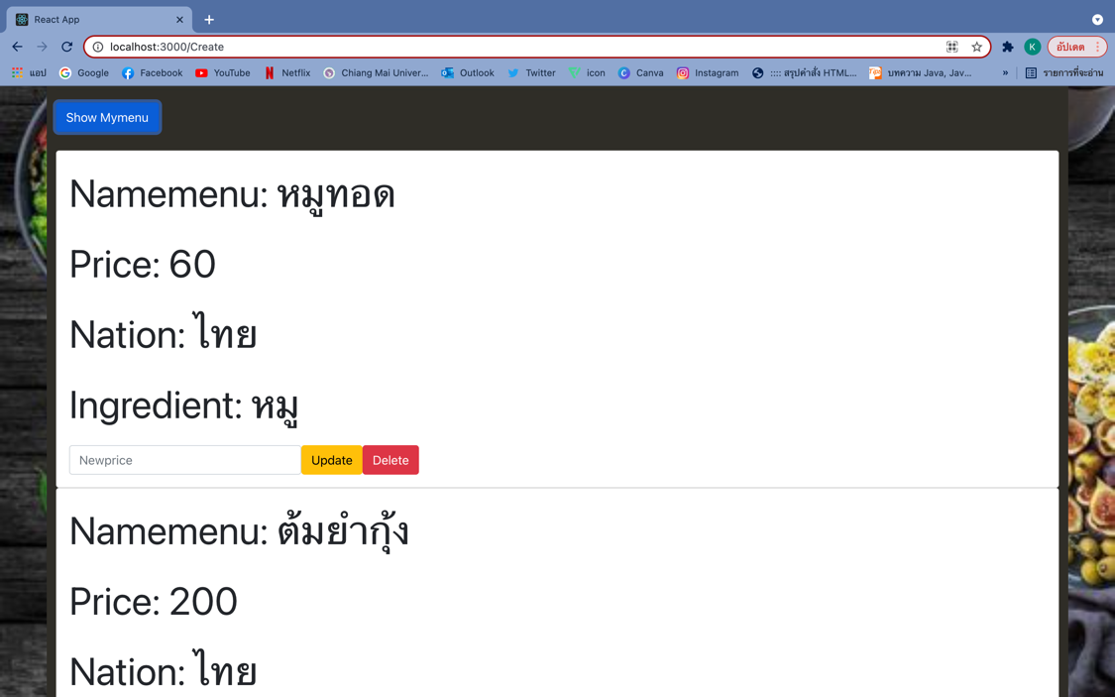

app.get("/Mymenu", (req, res) => {

db.query("SELECT * FROM mymenu", (err, result) => {

if (err) {

console.log(err);

} else {

res.send(result);

}

});

});

app.post("/mymenu", (req, res) => {

const namemenu = req.body.namemenu;

const price = req.body.price;

const nation = req.body.nation;

const ingredeint = req.body.ingredeint;

db.query(

"INSERT INTO mymenu (namemenu, price, nation, ingredeint) VALUES (?,?,?,?)",

[namemenu, price, nation, ingredeint],

(err, result) => {

if (err) {

console.log(err);

} else {

res.send("Values Inserted");

}

}

);

});

app.put("/update", (req, res) => {

const id = req.body.id;

const price = req.body.price;

db.query(

"UPDATE mymenu SET price = ? WHERE id = ?",

[price, id],

(err, result) => {

if (err) {

console.log(err);

} else {

res.send(result);

}

}

);

});

app.delete("/delete/:id", (req, res) => {

const id = req.params.id;

db.query("DELETE FROM mymenu WHERE id = ?", id, (err, result) => {

if (err) {

console.log(err);

} else {

res.send(result);

}

});

});

web server

**หน้าIndex**

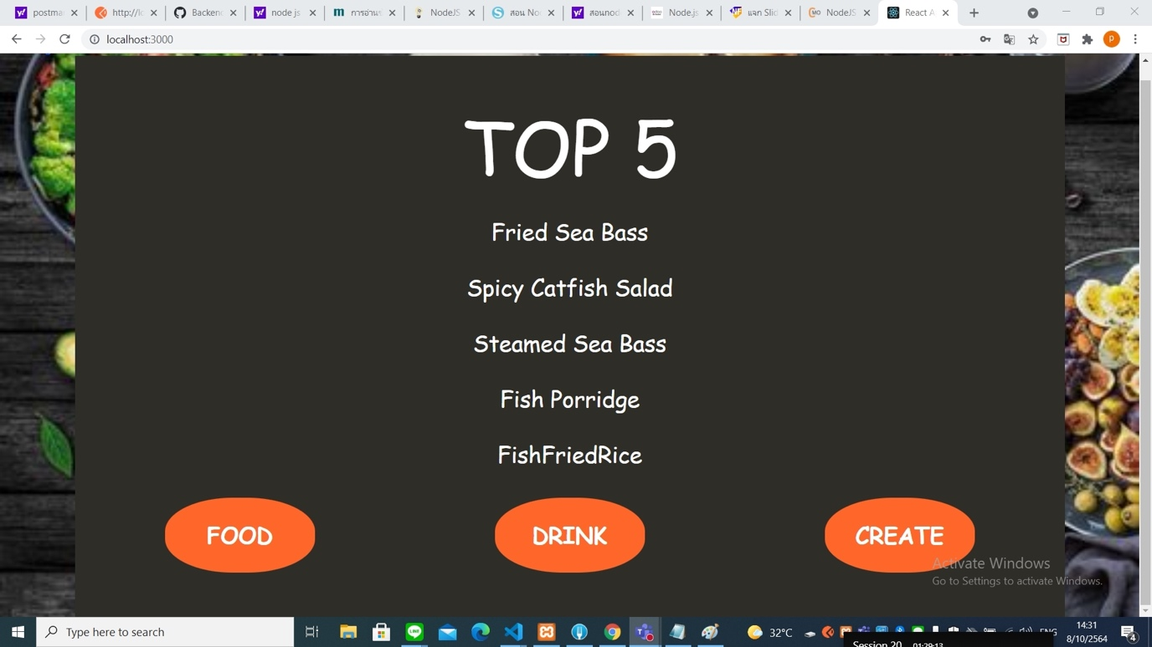

**หน้าLog in**



**หน้า random Nation**



**หน้า random Ingredient**



**หน้า menu Food**

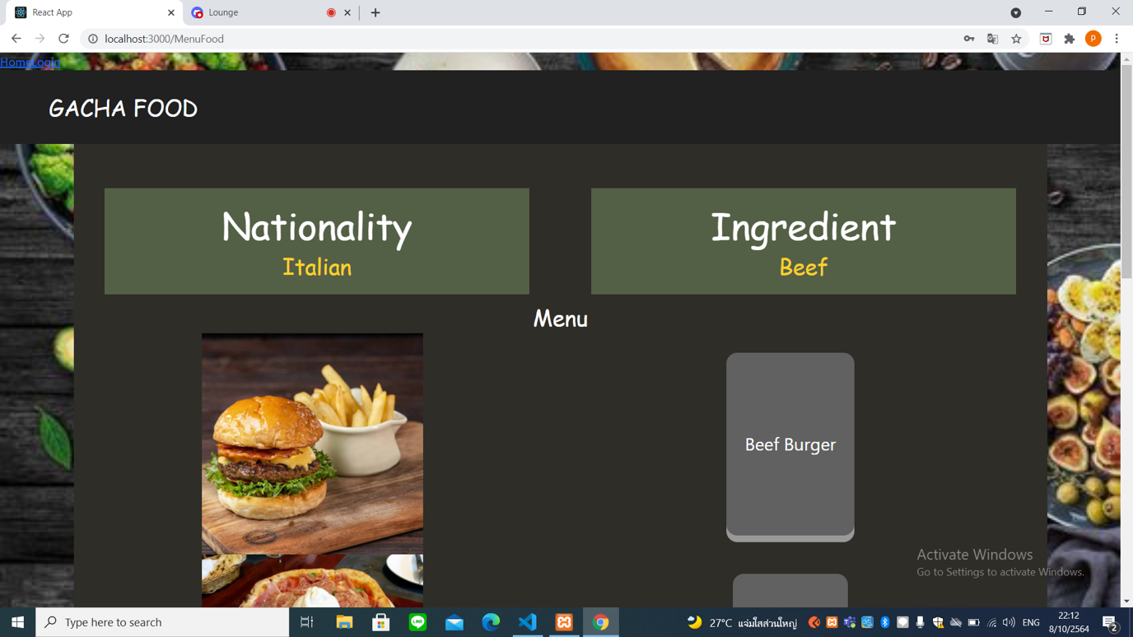

**หน้า list Food**

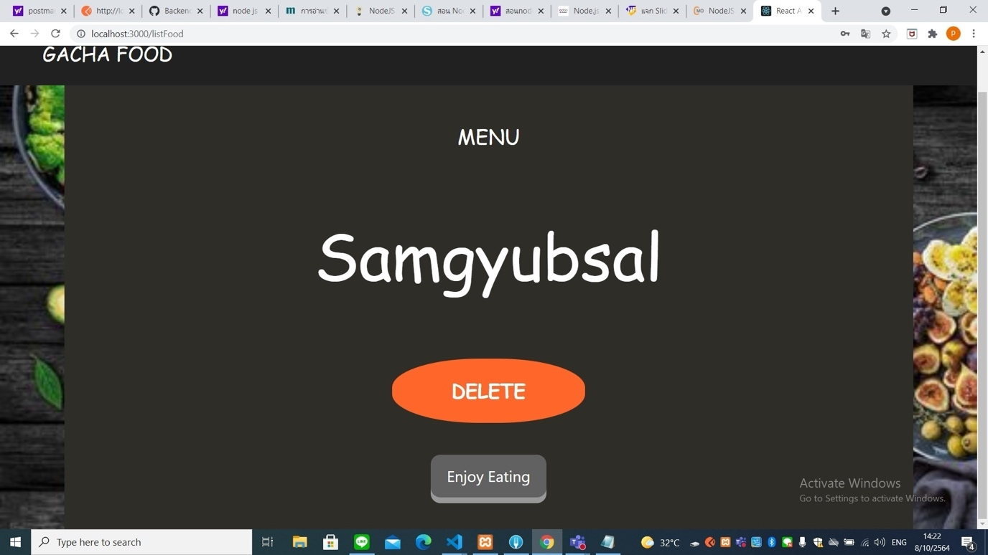

**หน้า random Drink**

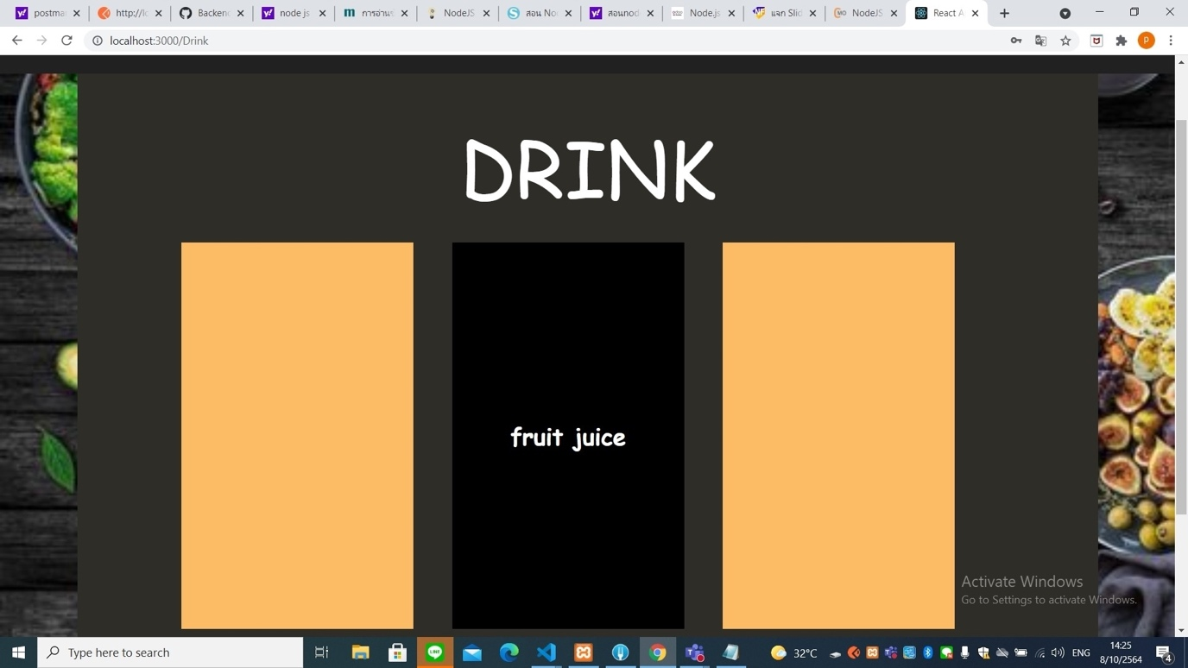

**หน้า menu Drink**



**หน้า list Drink**

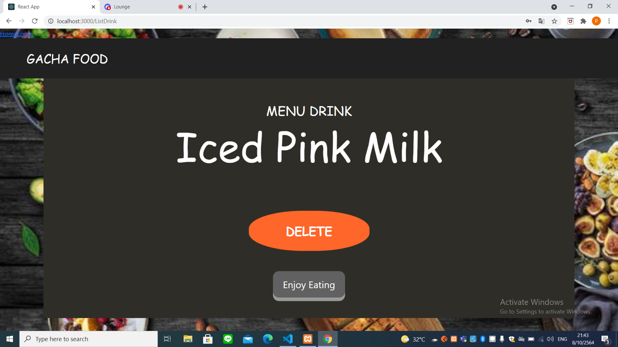

**หน้า Create**

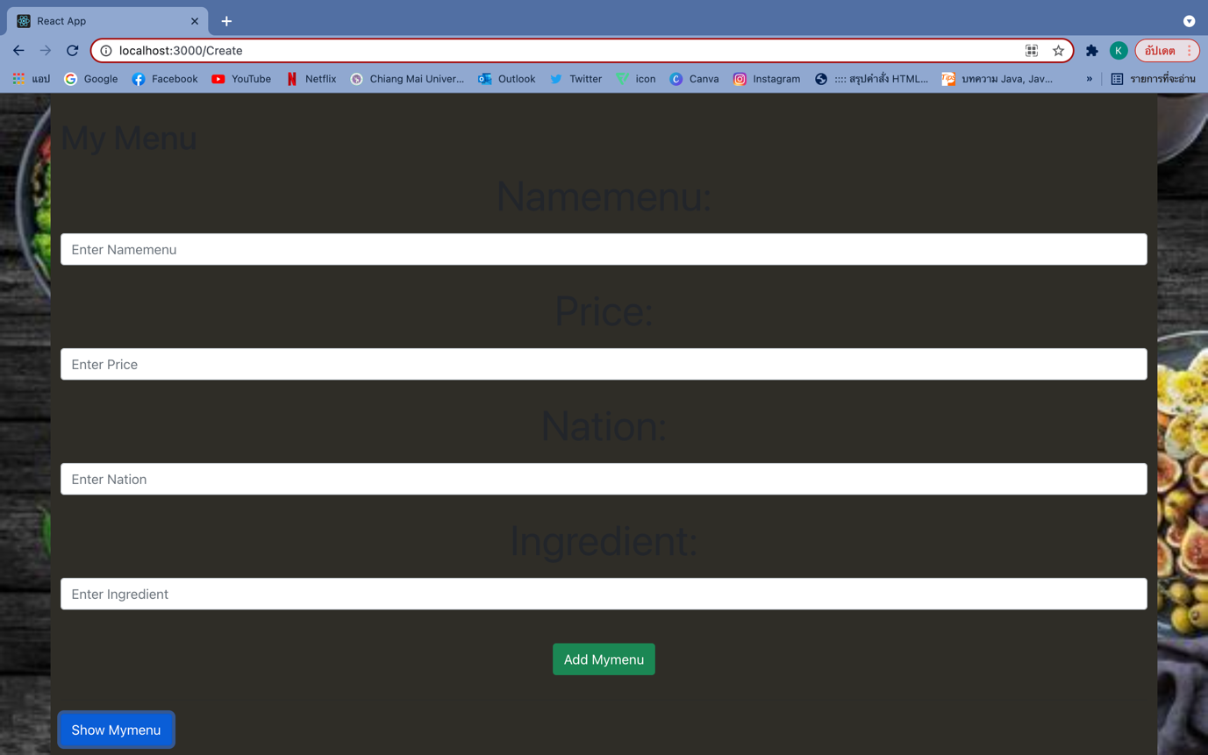

**หน้า add Create**

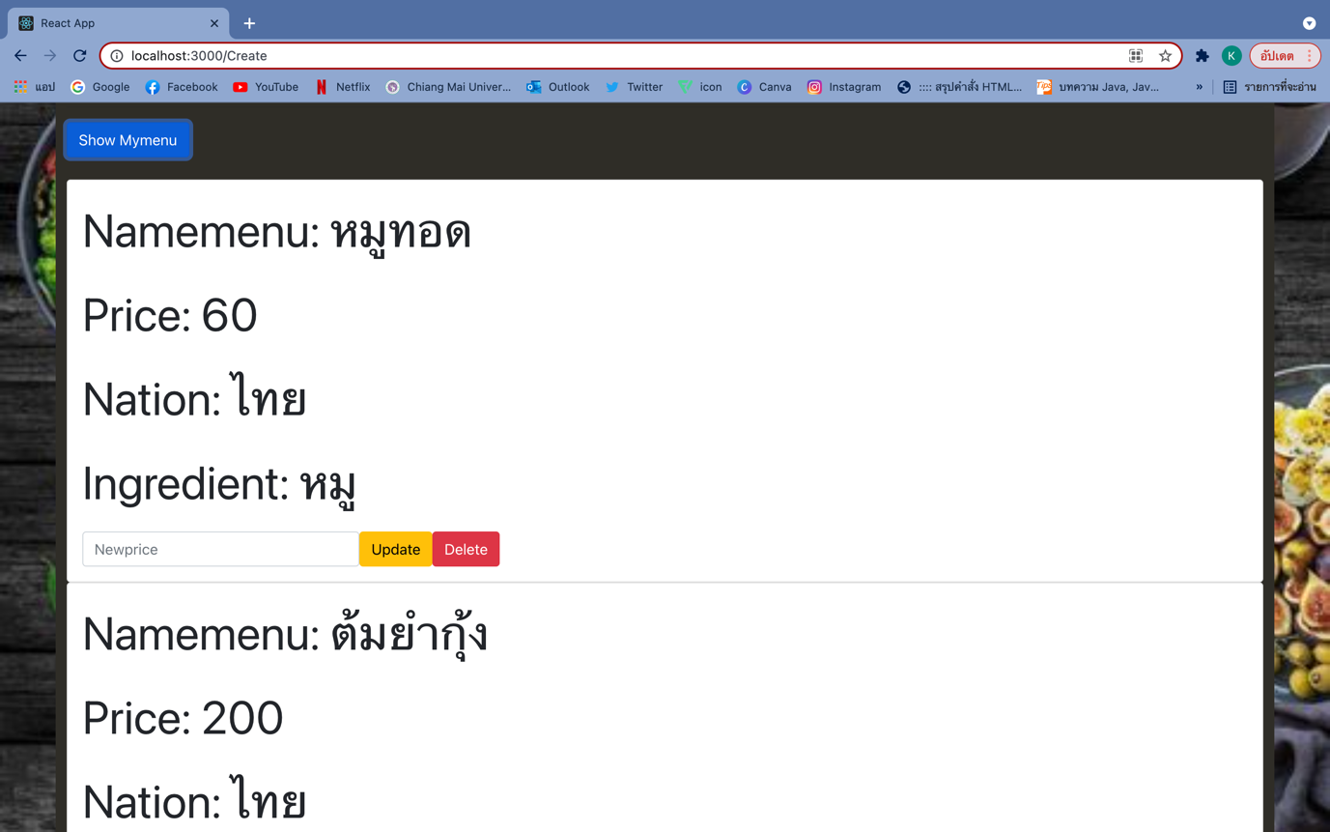

Database

เชื่อมกับDatabase

const connect = mysql.createConnection({

host: 'localhost',

user: 'root',

password: '',

database: 'camt_dii'

});

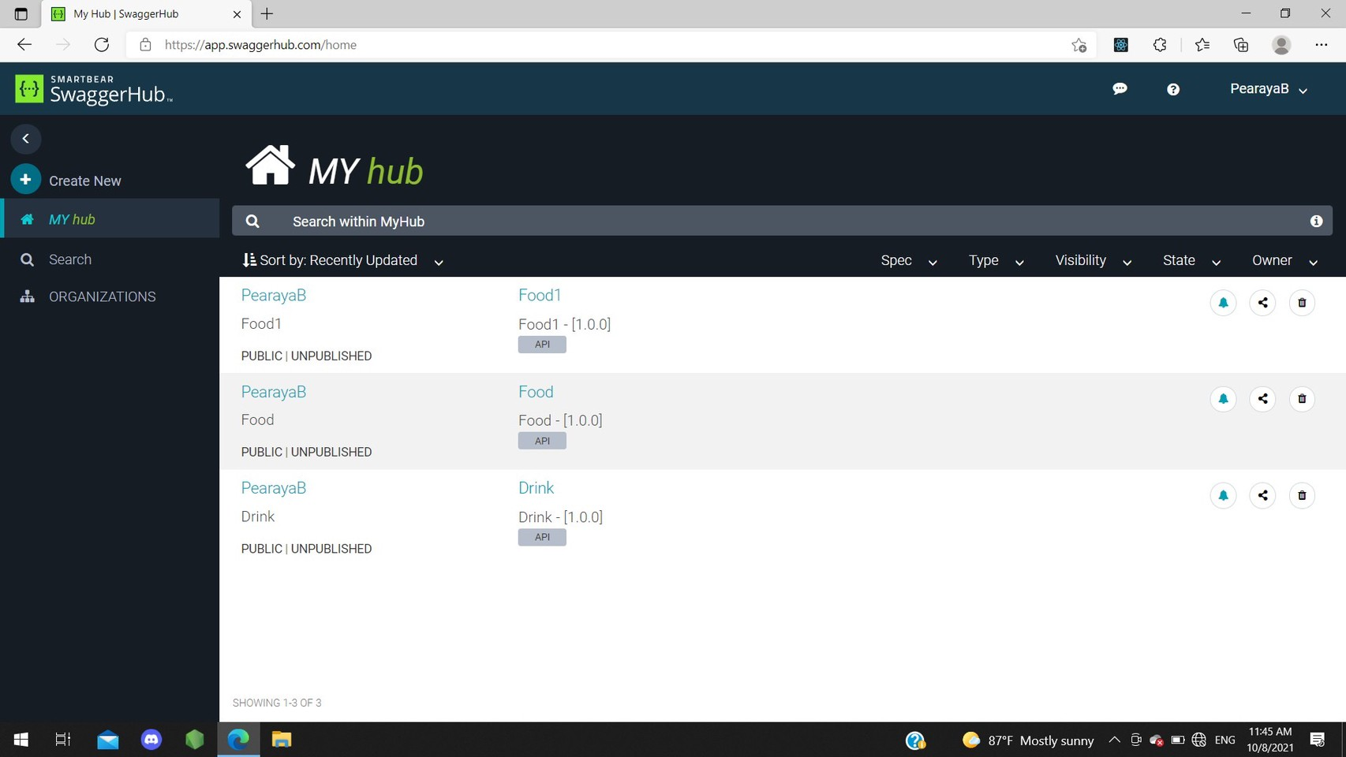

**Menu Food**

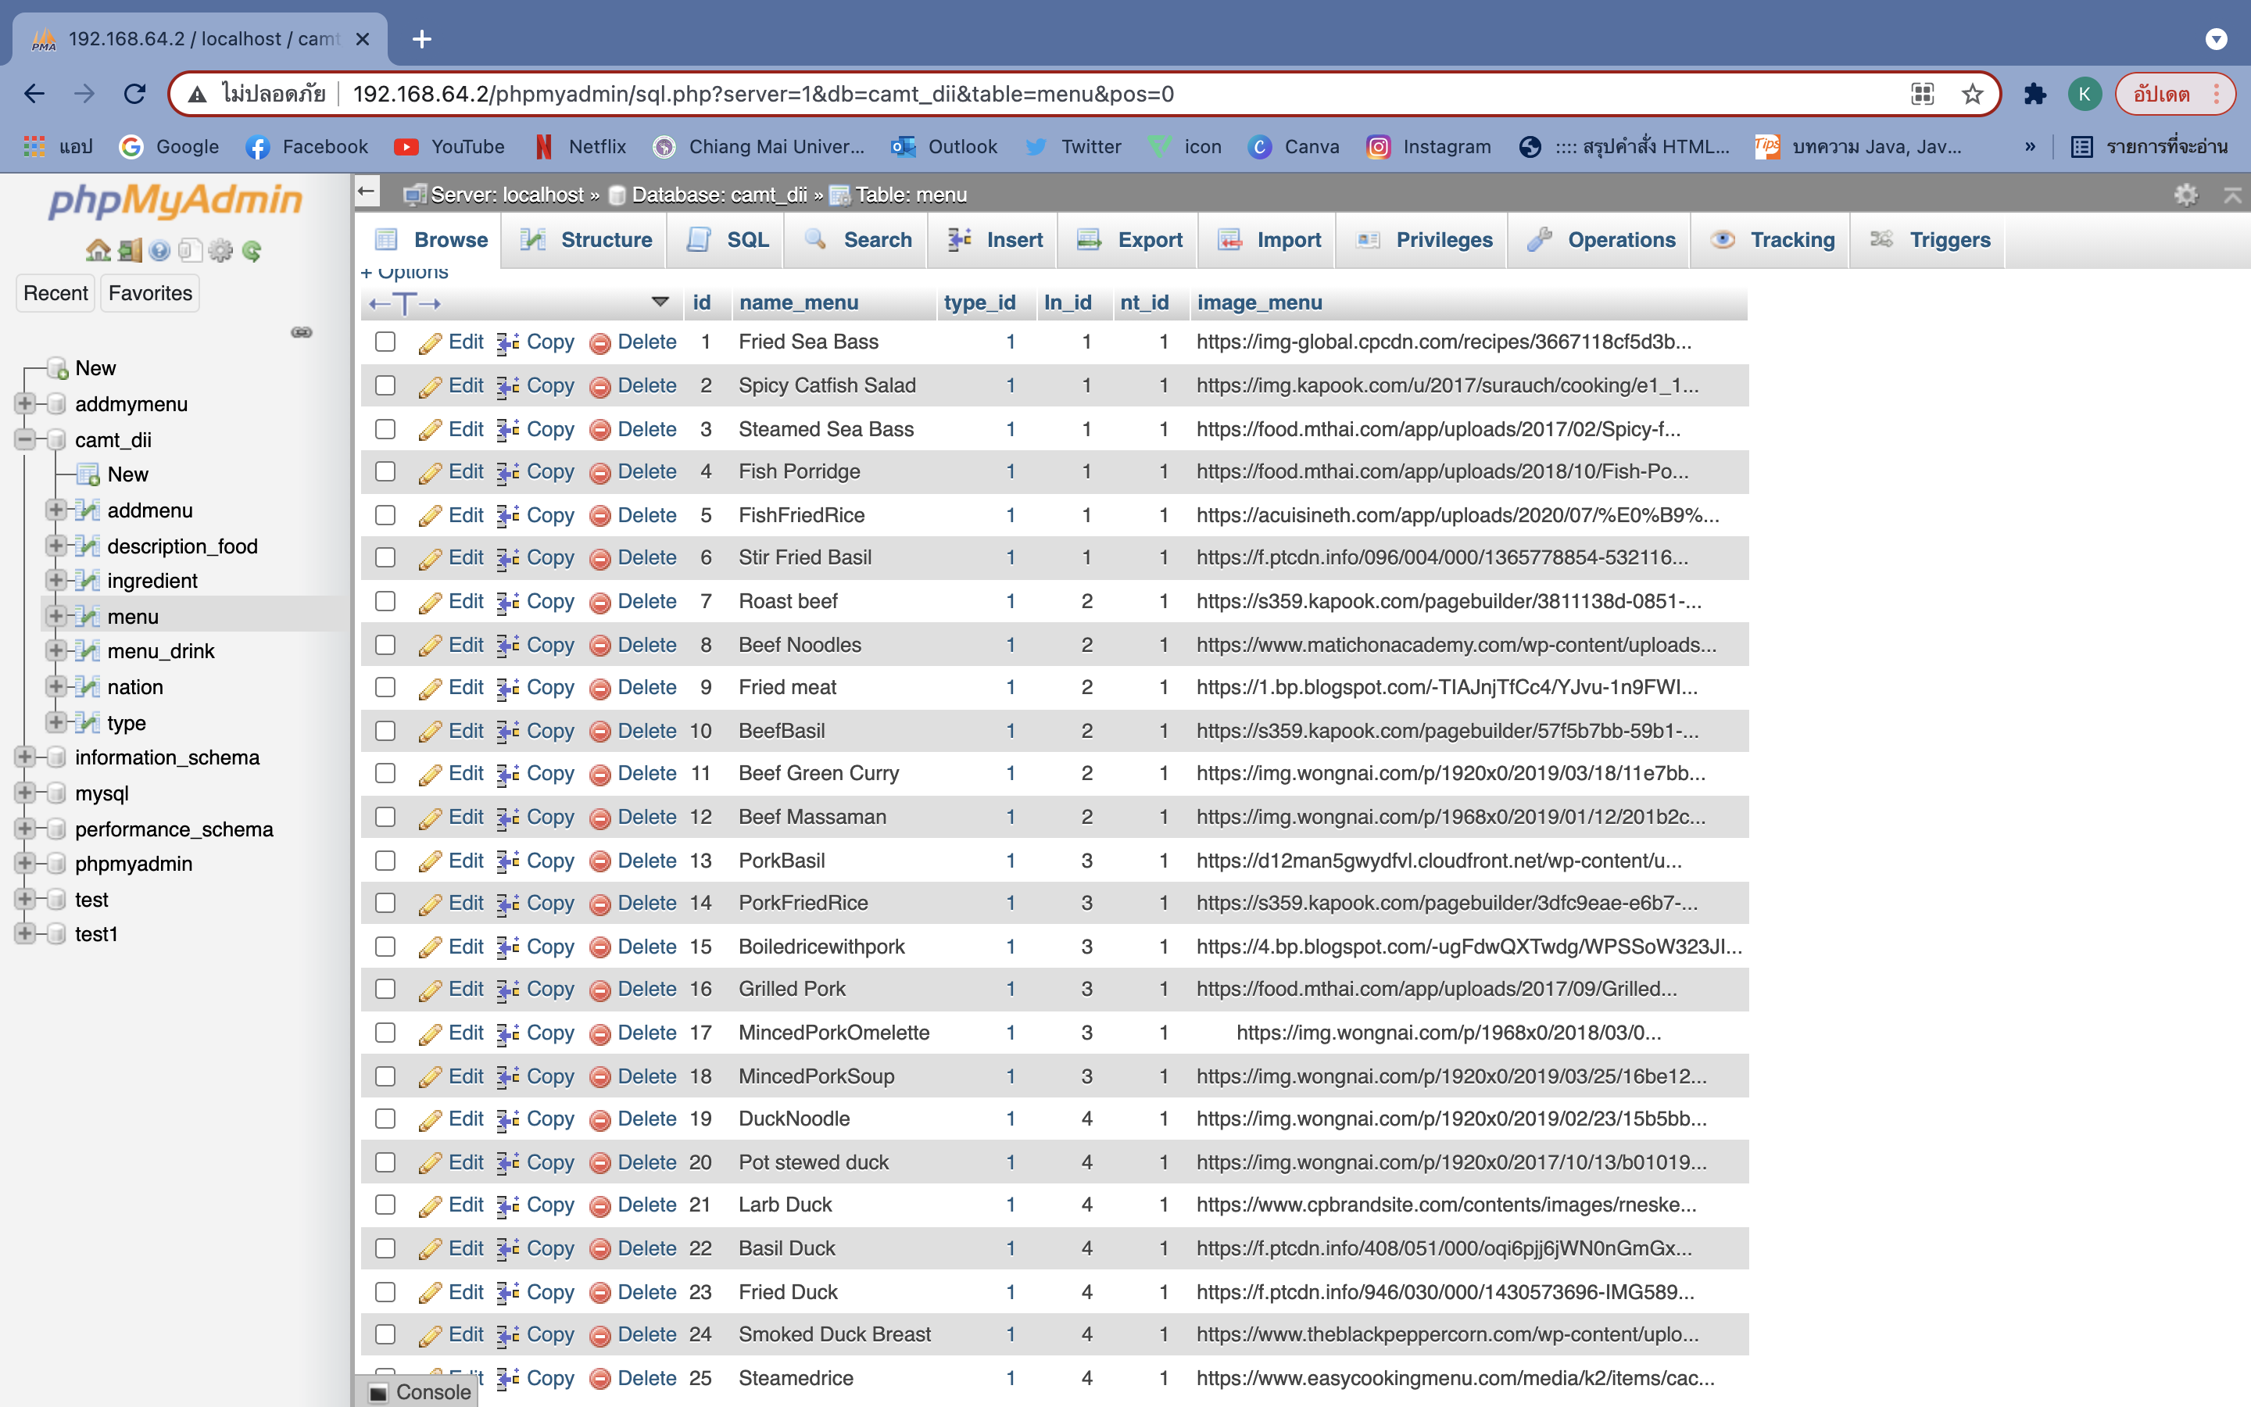

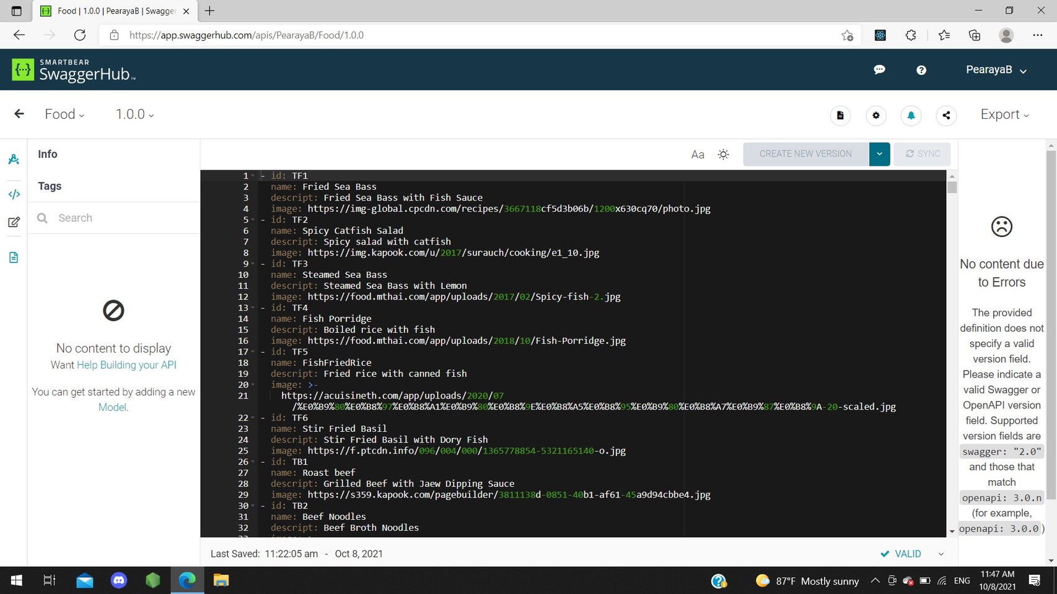

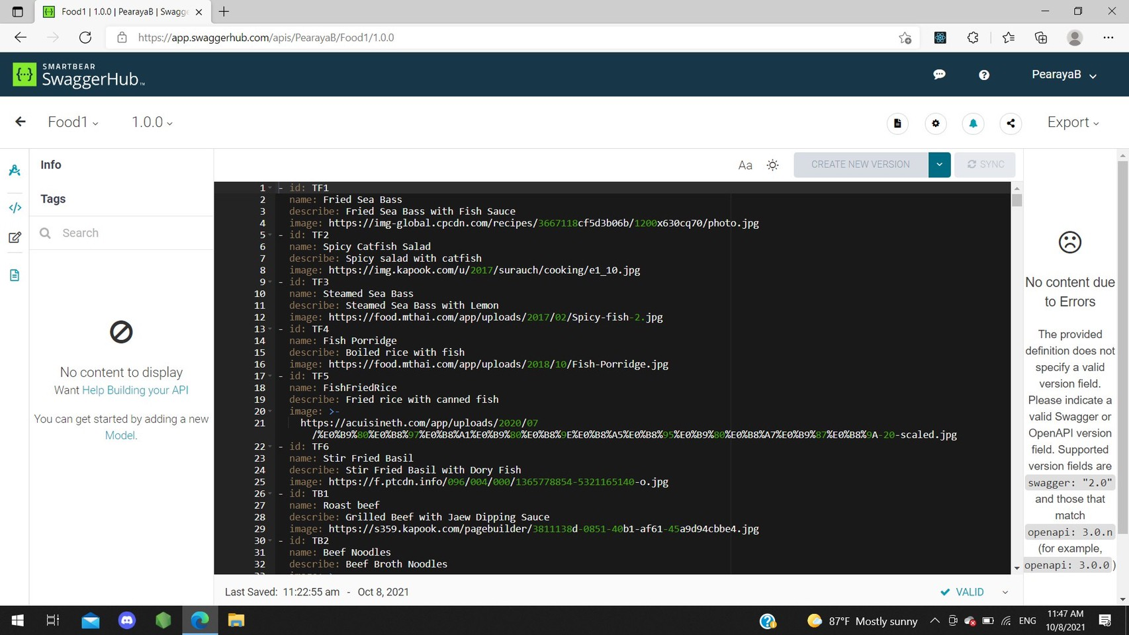

**Nation**

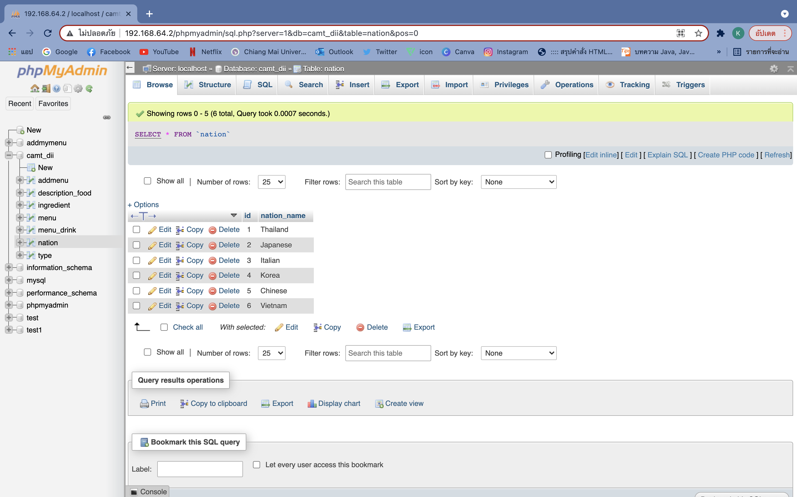

**Ingredient**

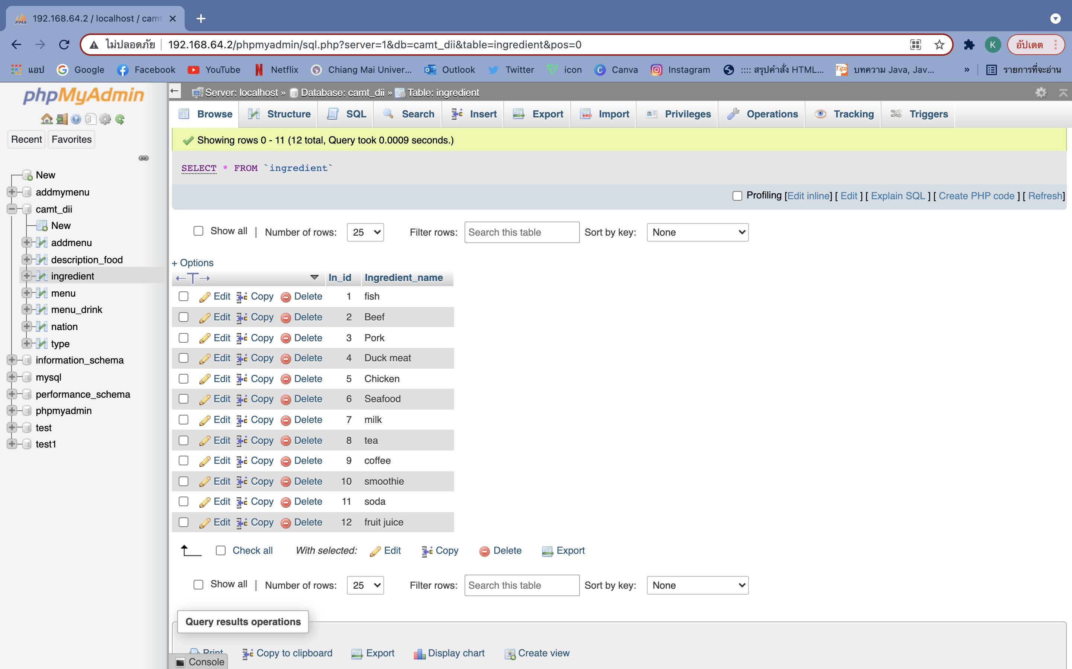

**Menu Drink**

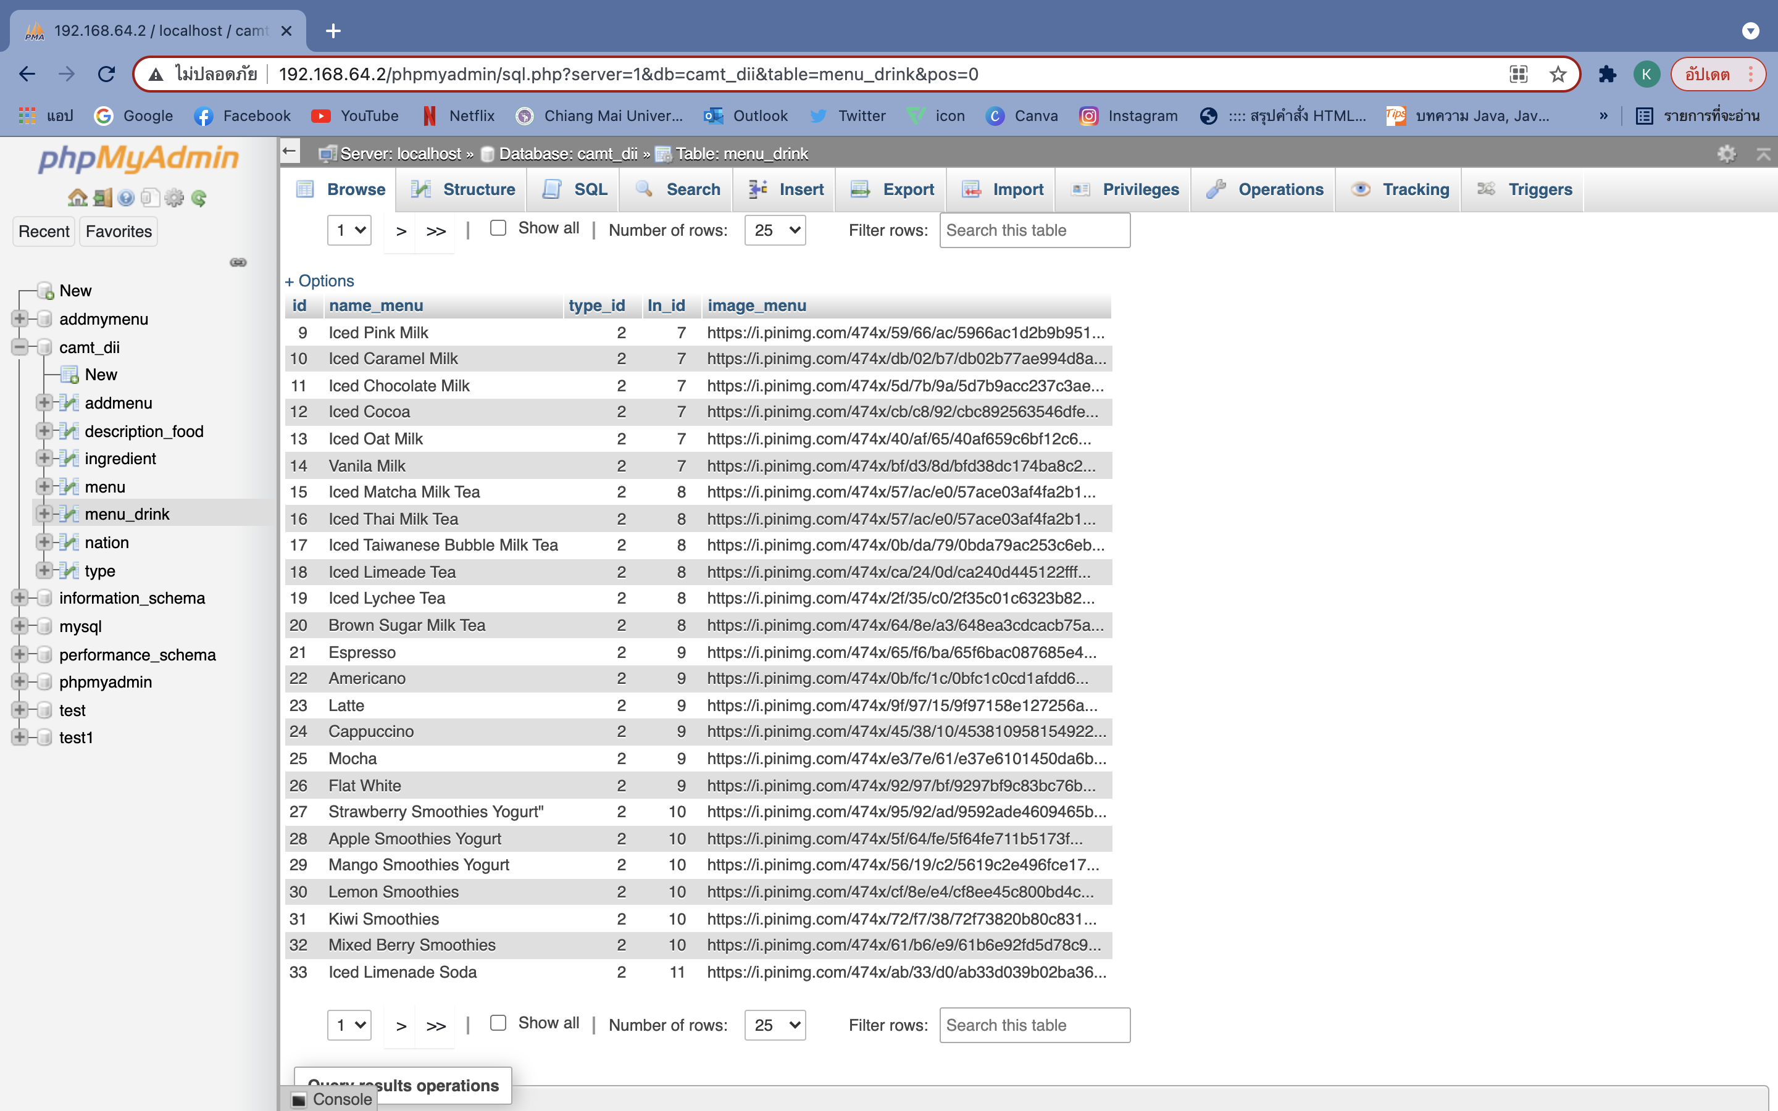

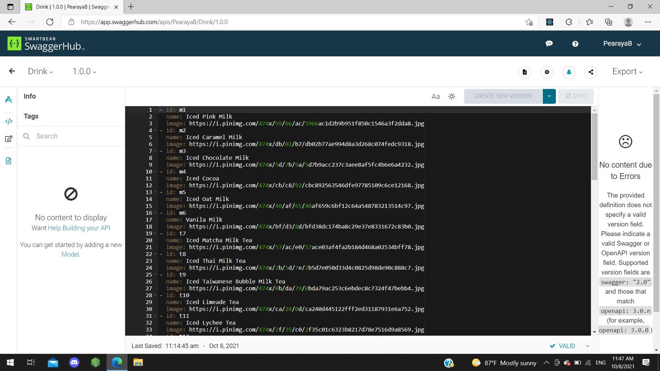

**Type**

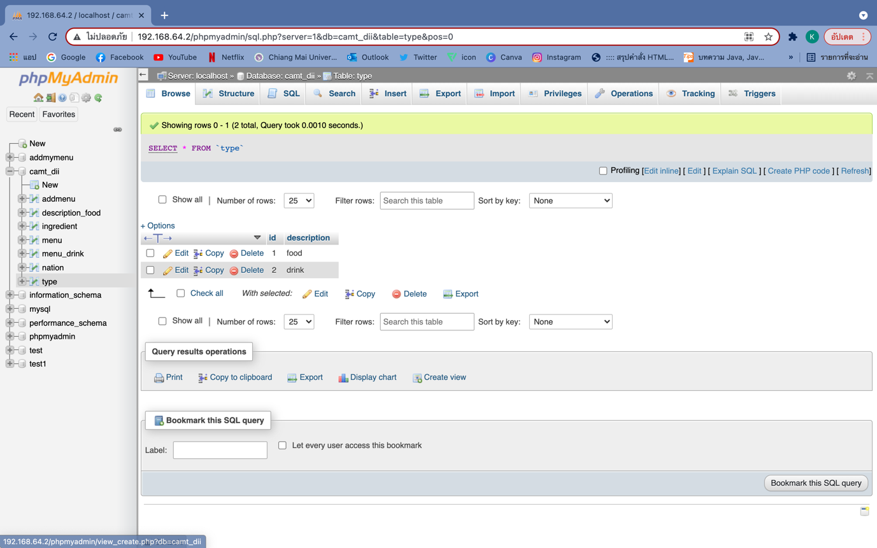

**Top Menu**

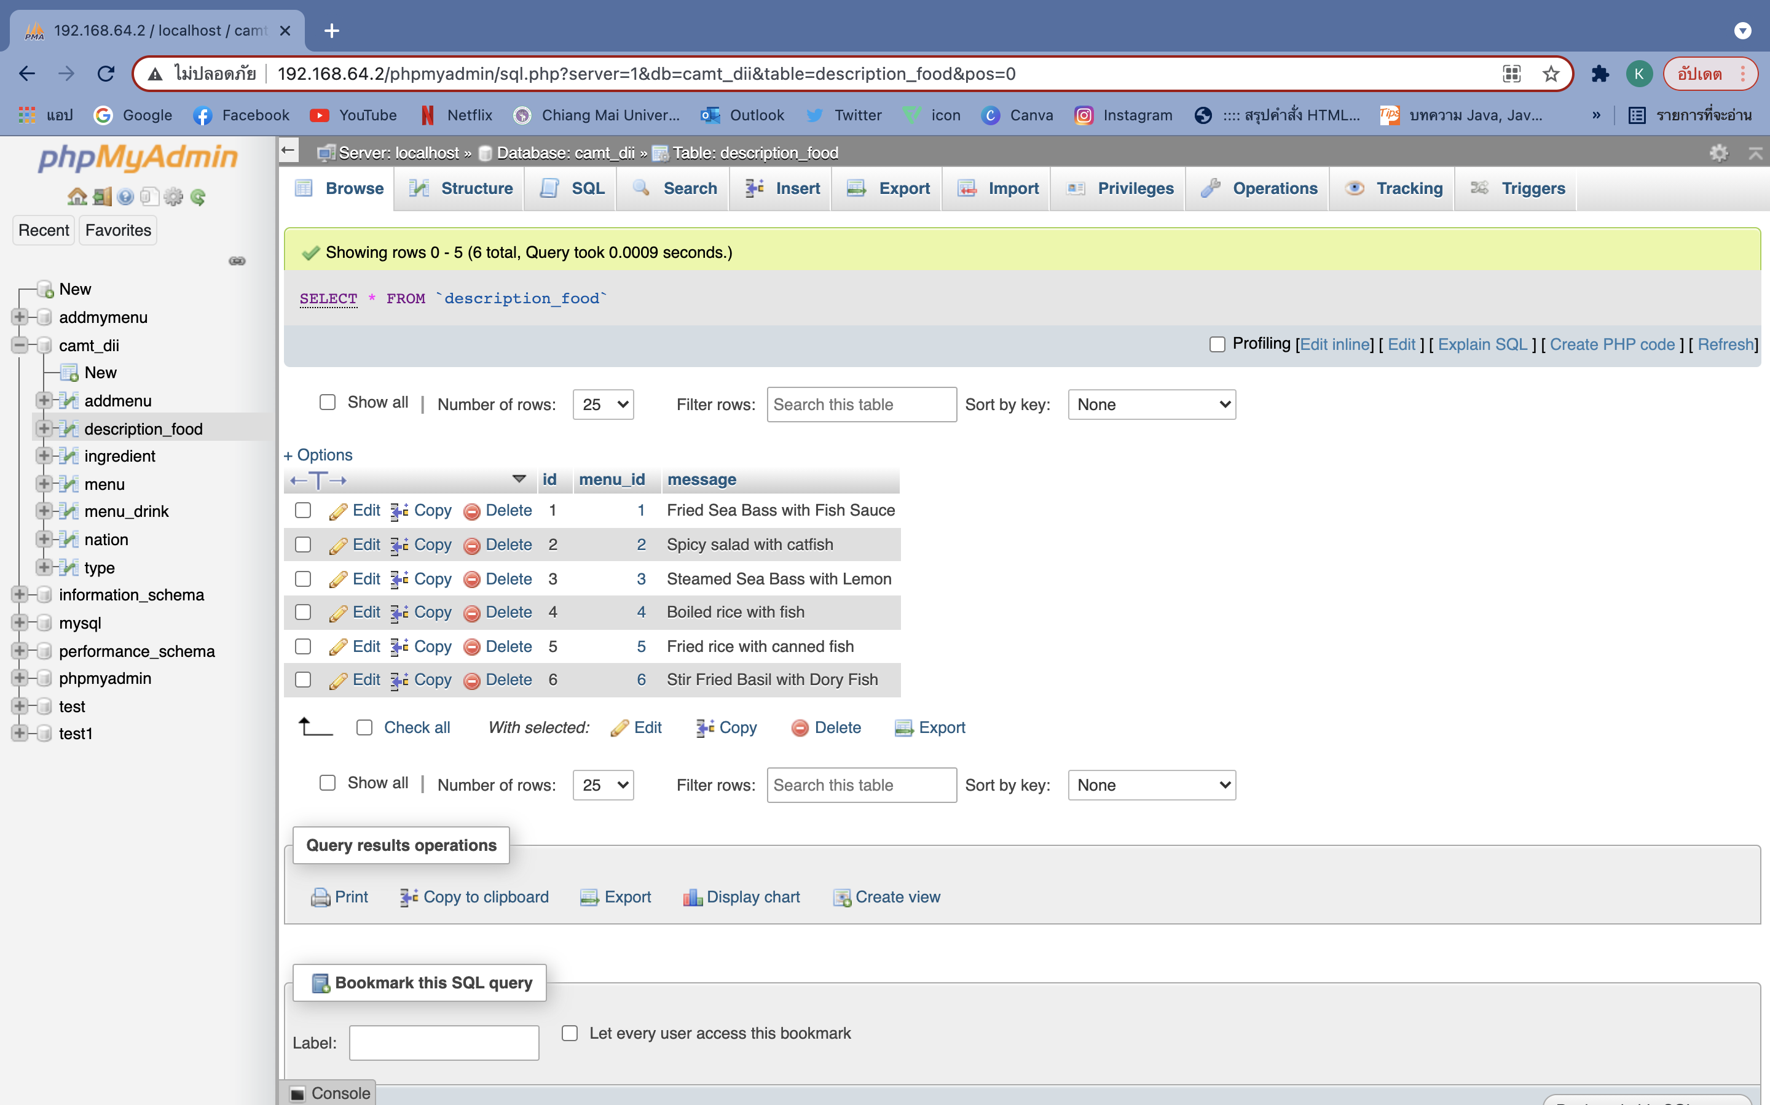

**Add Menu**

